Redes:
Rede externa na esquerda – 193.136.212.128/26
R1 – 193.136.212.190/26
PC1 – 193.136.212.129/26
PC2 – 193.136.212.130/26
Rede externa na direita – 193.136.212.192/27
R2 – 193.136.212.222/27
PC3 – 193.136.212.193/27
PC4 – 193.136.212.194/27
Rede externa no meio – 193.136.212.224/29
R1 – 193.136.212.225/29
R2 – 193.136.212.226/29
R3 – 193.136.212.227/29
Rede do servidor – 10.90.0.0/24
R3 – 10.90.0.254/24
Server – 10.90.0.1/24

Comandos usados na configuração dos dispositivos:
R1:
conf t
interface e0/0
ip address 193.136.212.190 255.255.255.192
no shut
exit
interface f1/0
ip address 193.136.212.225 255.255.255.248
no shut
exit
ip route 193.136.212.192 255.255.255.224 193.136.212.226 – rota estática para rede externa direita
exit
R2:
conf t
interface e0/0
ip address 193.136.212.222 255.255.255.224
no shut
exit
interface f1/0
ip address 193.136.212.226 255.255.255.248
no shut
exit
ip route 193.136.212.128 255.255.255.192 193.136.212.225 – rota estática para rede externa esquerda
exit
R3:
conf t
interface e0/0
ip address 10.90.0.254 255.255.255.0
ip nat inside
no shut
exit
interface f1/0
ip address 193.136.212.227 255.255.255.248
ip nat outside
no shut
exit
ip route 193.136.212.128 255.255.255.192 193.136.212.225 – rota estática para rede externa esquerda
ip route 193.136.212.192 255.255.255.224 193.136.212.226 – rota estática para rede externa direita
access-list 1 permit 10.90.0.0 0.0.0.255 – criação de lista para SNAT com rede do server
ip nat inside source list 1 interface f1/0 overload – criação da tabela SNAT com recurso a overload
ip nat inside source static tcp 10.90.0.1 80 193.136.212.227 80 – configuração DNAT para server
exit
PC1: ip 193.136.212.129/26 193.136.212.190
PC2: ip 193.136.212.130/26 193.136.212.190
PC3: ip 193.136.212.193/27 193.136.212.222
PC4: ip 193.136.212.194/27 193.136.212.222

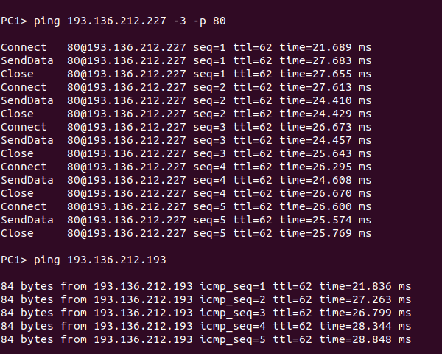
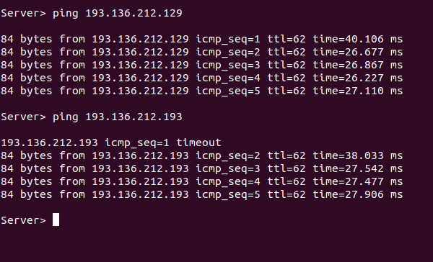
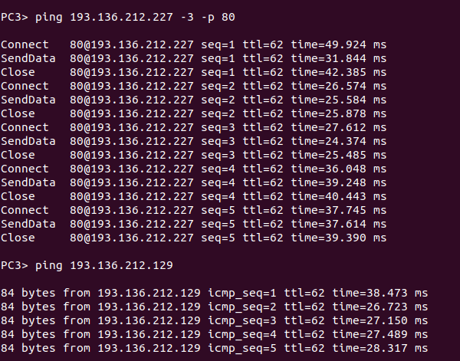
Ping da rede direita para as outras
Ping da rede esquerda para as outras
Ping da rede do meio para as outras

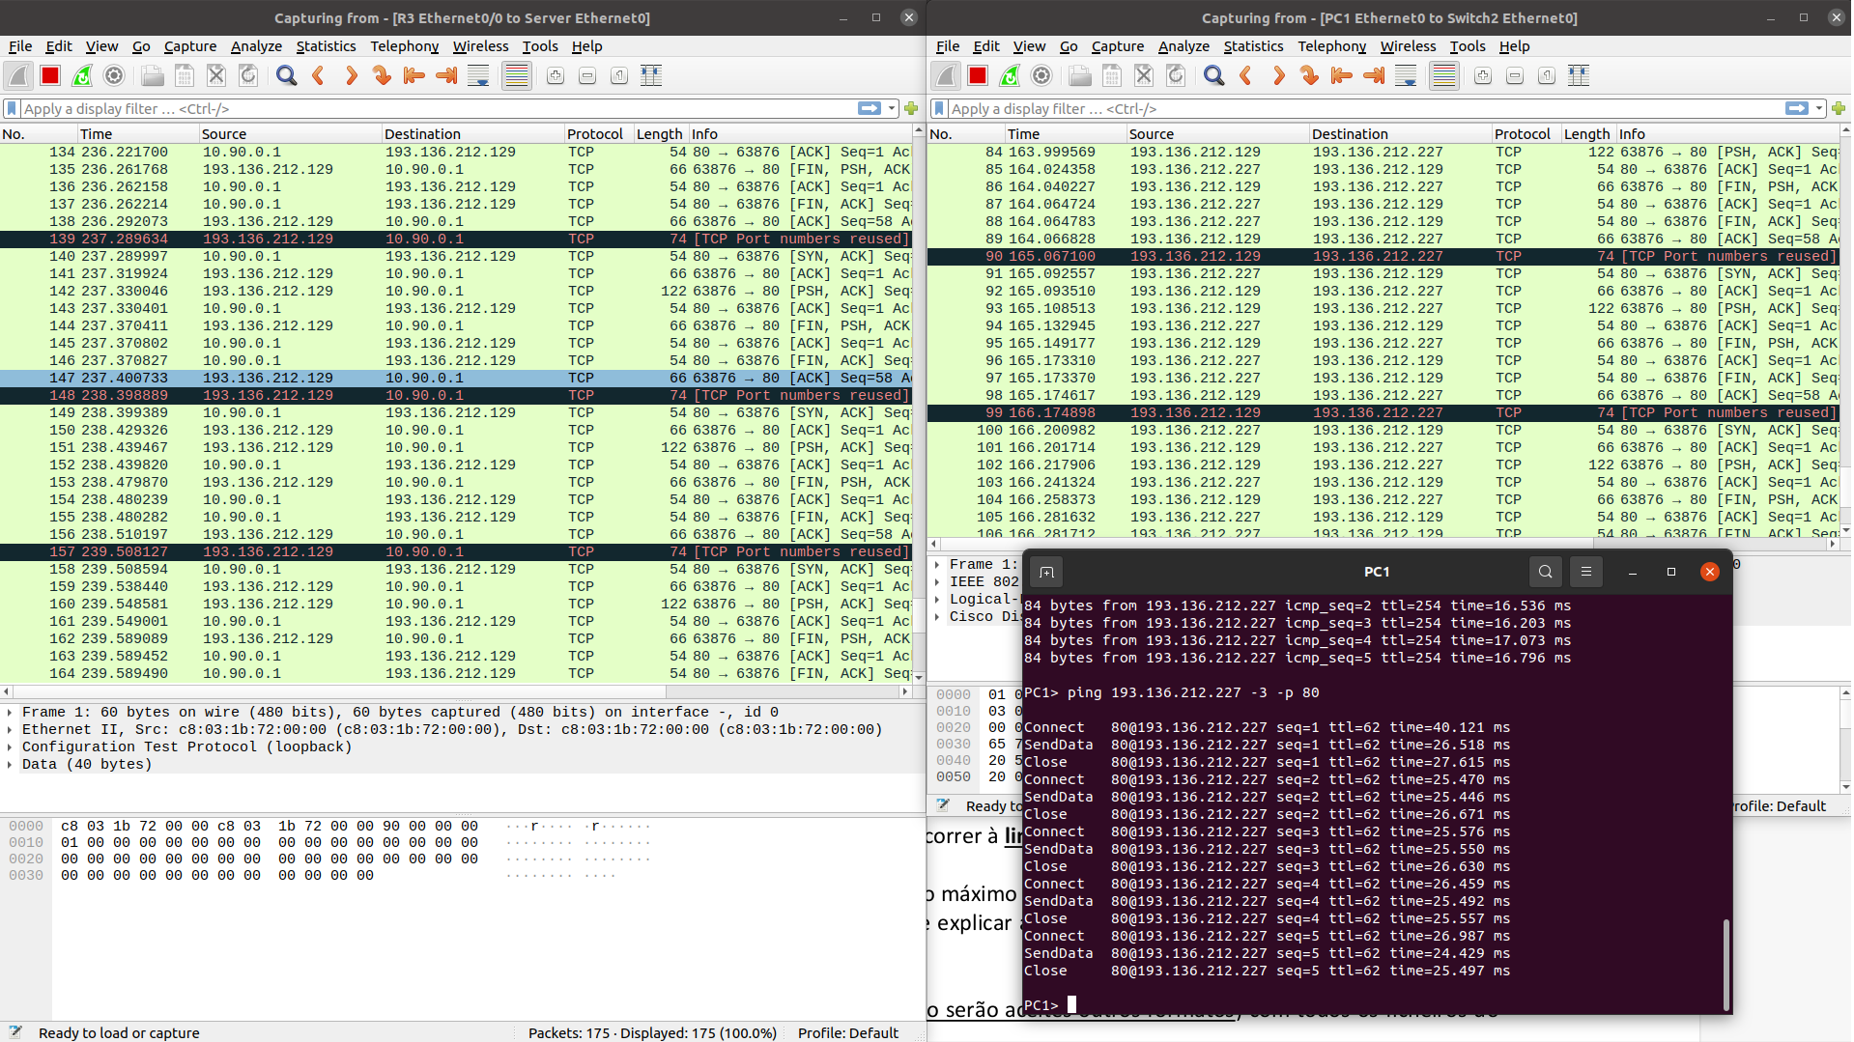
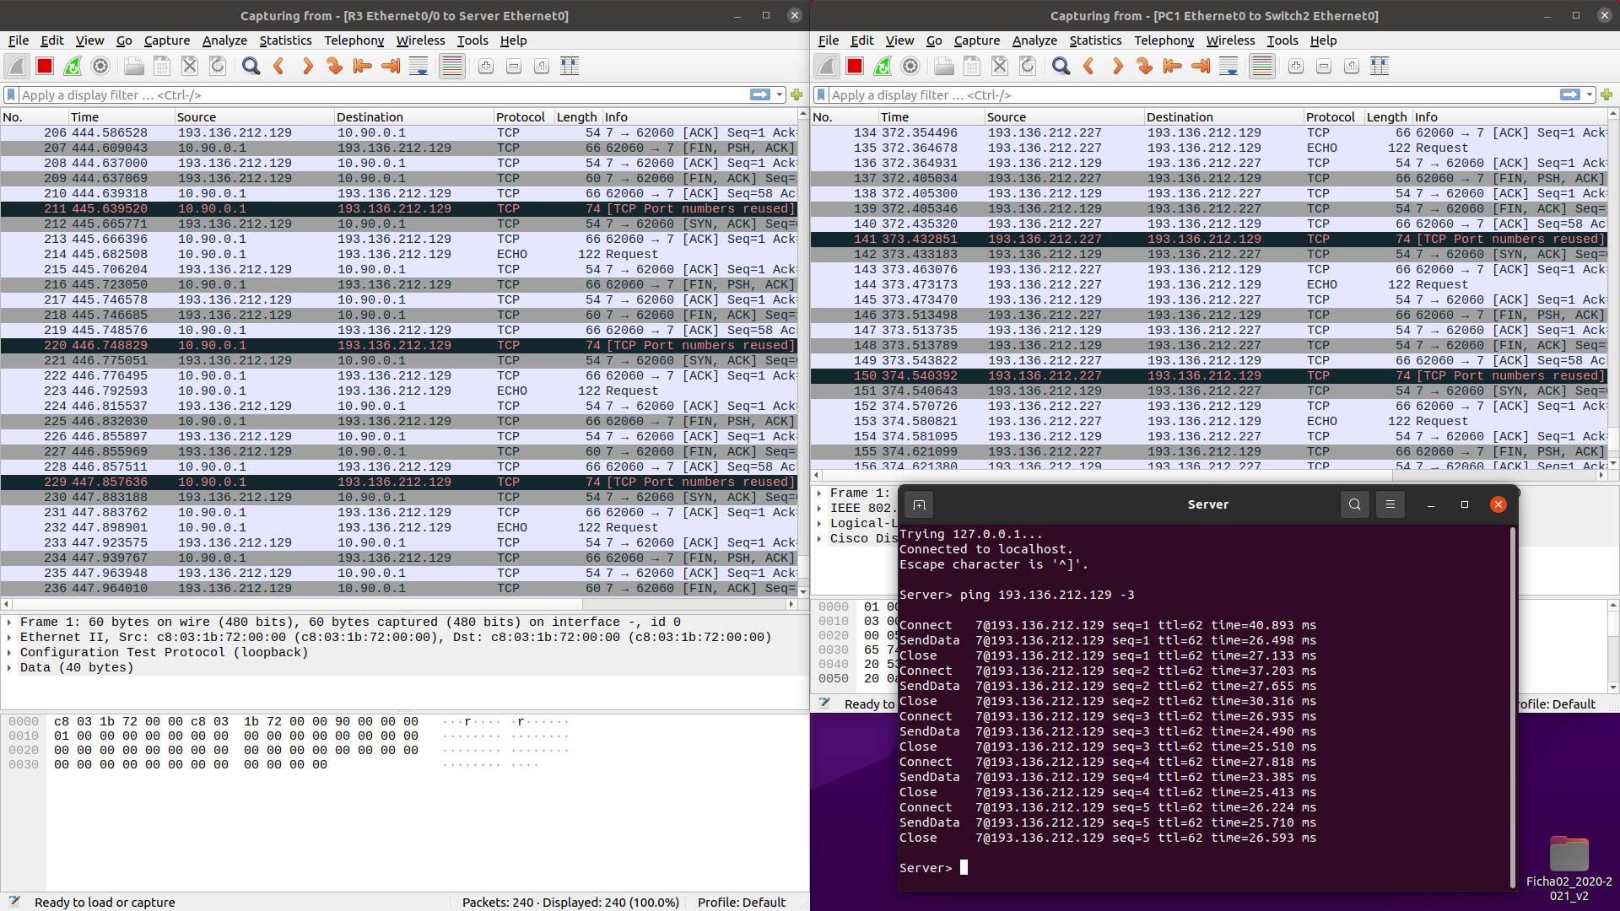
Teste DNAT
Teste SNAT

